**Chapter 1**

* Living in the information age because of low cost computing, high internet speeds, good storage of info
* Benefits of IT is efficiency (automation) but may lead to less jobs (not sure if offsetted by more IT roles)
* General skills are more wanted from IT professionals than technical skills
* IT professionals have many different roles stemming from their past background in science, math, engineering
* IT professionals have many different types of environments
  + Individual offices (easy to concentrate, remove interruptions)
  + Open plan offices (Individual cubicles with other rooms for private meetings)
  + Hot-desking (staff do not have pre-allocated spaces because of unpredictable work times)
  + Telecommuting (Working from home or other locations)
* Communication has 4 components
  + Who is speaking?
  + To whom it is said
  + How is it said
  + What is said
* Lasswell’s Communication Model: 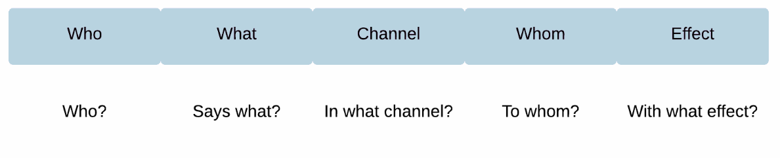
* Shannon-Weaver Model
  + Like Lasswell’s Model
  + Noise is the interference between what is sent and then what is received
    - Occurs in the channel so it can be technical problems OR it can also be semantic issues or communication issues
  + 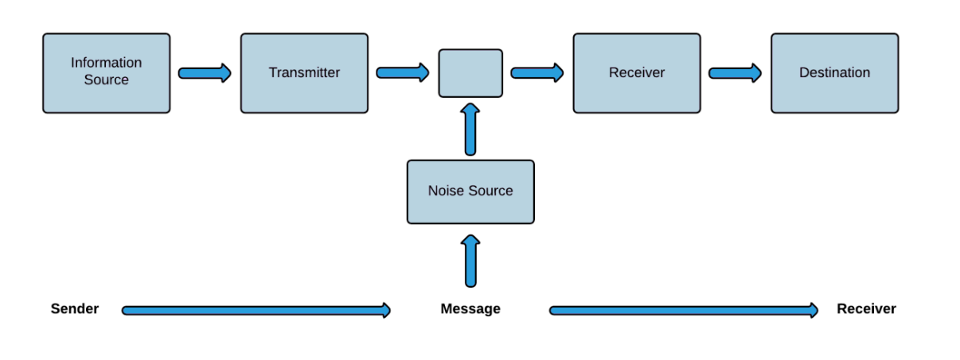
* Priestly’s Paradox: The more we elaborate our method of communication, the less we communicate
  + When elaborating our communication with technological layers, are we communicating less effectively? (Using email means that we cannot show body language, more assumptions need to be made by the receiver)
  + Is using short communications (SMS) a reduction in the elaboration of the communication, so we are communicating more effectively?
* Communication tips
  + Show empathy and understand the listener’s perspective
  + Consider the receiver of communication (avoid jargon if they wouldn’t know it)
  + Avoid sounding superior
  + Face-to-face/direct communication can resolve confusion or misunderstandings
  + End conversations by agreeing on the next steps

**Chapter 2**

* Communication is the way people express themselves so other people can understand
* The types of communication are **interpersonal, organisational, team-based, public relations, intra-personal**
* Intra-personal communication is the internal expressions and understandings that occur within ourselves and others
* Emotional intelligence is the capacity to recognise and utilise emotion to interact and communicate more effectively
* Emotional competency is the personal and social skills that lead to superior performance in work
  + Divided into personal competence (how we manage ourselves) and social competence (how we manage relationship with others)
* Interpersonal communication is the process of sending and receiving info between two or more individuals
  + Focusing on assertiveness, listening, questioning, feedback
* Assertiveness is obtaining our desired outcomes from others without contravening their rights
  + Say No if you disagree and give an alternative
  + Dismiss and redirect conversation
  + Giving a question to someone to prompt awareness
  + Fogging is where we calmly acknowledge criticism rather than being defensive
  + Forcing a choice (if given multiple tasks, need to clarify which objective should be prioritised)
  + Broken record (clearly and calmly repeating the message, without getting frustrated/distracted)
  + Ask for specifics (Finding useful feedback out of harsh criticism)
  + Workable compromise (Trying to find a compromise)
  + Threat (last resort)
* Listening abilities vary with power and gender
  + Higher-power and males tend to interrupt lower-power and females more
  + Non-verbal cues are important to interpreting other’s communication
    - Can also make our own communications effective (by giving them non-verbal feedback)
  + Barriers to effective listening involve changing the subject, daydreaming, not paying attention, ignoring non-verbal cues
  + Can actively listen by using minimal verbal responses to spur the speaker to articulate and clarify their meaning
    - Listen to the speaker → Seek feedback from the speaker to ensure we have understood properly
* Questioning skills (getting useful responses with effective questioning techniques)
  + Different types of questions (direct probe, open, closed, objective criteria, testing, hypothetical, reflective, leading)
  + Need to use the right question for the right circumstance
  + All questions range from open to closed
    - Open questions are useful for breaking the ice and inciting a broader discussion
    - Closed questions are good for establishing facts, getting commitments or choices from others, can achieve closure or precision
* Effective feedback gives the receiver advice, support or constructive criticism
  + Need to manage tone and maintain a positive perspective when receiving feedback
  + Effective feedback has both positive and negative aspects
  + Should be fair, accurate, specific, formally structured, solution oriented
  + Should go for a 5:1 ratio of positive: negative feedback
* Intercultural Communications is the process of sending and receiving unambiguous and clear communication between individuals of different cultures
  + Culture is not just race or religion but people with different values and opinions
  + Should not rely on stereotypes from race/religion
  + Can improve cross-cultural communication by
    - Preparing and trying to understand their culture of the individuals
    - Reduce uncertainty by engaging in effective communication techniques
    - Recognise differences
    - Adjust your communication based on differences in culture
    - Recognise culture shock

**Chapter 3**

* Research is actively finding info new to the researchers
* Four stages of research (CASI) are
  + Collection (finding info and data for research)
  + Analysis (transforming data to info, discarding useless info, turning anything valuable into something useful for research)
  + Synthesis (processing info to understand connections, look at all the info and how they’re connected to each other, BIGGER PICTURE)
  + Insight (How the research connects with other knowledges in different fields)
* Research styles of
  + Theoretical research (propose a theory about a matter)
  + Quantitative research (researcher conducts research and collects data which is numerical in nature)
  + Qualitative research(Research and collection of data which is non-numerical (interviews/observations))
* Information sources
  + Library
  + Catalogues
  + Internet - Need to consider when the site was last updated, who created the site and their credentials, what is the purpose of the site (advertisement for a product or purely for info)
  + Electronic databases
  + Metacrawlers
* Need to consider two areas: finding/identifying info and then how to manage what we want to keep so we can find it again
* Information can be 3 types
  + Primary data: Data that lies closest to the source of truth. Original data that was collected and analysed by researchers (experimental data, interviews)
    - Published in journals, conference papers, reports
  + Secondary data: Reanalysis or previously collected survey or other data that were originally gather by others
    - Sources that cite or quote primary sources or interpret the sources
    - e.g. A review of a set of interviews
    - Published in review articles, journalistic news stories, textbooks
  + Tertiary data: Where a researcher brings primary and secondary data
    - e.g. Encyclopedias
* Attributes of Information (CAAAS)
  + Currency: How up to date the info is
  + Accuracy: Whether the information is correct (verified by checking multiple sources)
  + Authority: Who the author is, where the info was published, what sources were used by them
  + Accessibility: How easy it is to access the info
  + Stability: How likely the info is to remain the same
* Dewey decimal system is used to organised published material
* Need to consider how we are going to present our information well through the medium (report, presentation)
* Bibliography is work that is relevant to your topic but not referred to directly. Reference list includes work that is referred to directly
* Referencing is done to show support for your idea, give details of the sources you used, ensure someone else can find the same material
* Can include info from other sources by paraphrasing or quoting
  + Quoting is the exact words of another author/source
  + Paraphrasing is not using the author’s exact words but rephrasing with words but keeping the same idea
* Plagiarism is using another source without citing

**Chapter 4**

* Oral Delivery can have advantages like
  + Using attributes unique to verbal communication
  + Can be more dynamic than other forms of communication
    - Speaker can tailor to specific audience and manage the audience’s engagement
  + Enable the use of supplementary materials like audio/visual materials (slides or videos)
* Can also have disadvantages like requiring good public speaking skills and requires coping well with spontaneity (hecklers, talk during the presentation)
* Oral presentations go through two stages of preparation and delivery
* Preparation
  + Need to understand the objective of the presentation (to inform or to persuade) → Allows for easier preparation
  + Speaking to different audiences involves changing language and content, how casual or formal you need to sound like
  + Need to also consider the forum (the place where the presentation is to take place and if there is any IT equipment in that place that may help)
* Structuring presentation content
  + Need to build a logical structure so that it is easier to understand
  + Need to use an effective introduction and conclusion
  + Grab the audience’s attention
  + Use a plan
  + When making slides need to consider content, fonts, animations and images/figures/videos
  + Use notes to loosely keep you informed on the presentation structure
* Delivering presentations
  + Manage timing to ensure finishing on time
  + Managing discussion and taking questions
  + Also need to consider non-verbal communication (body posture and movement, hand gestures, eye contact,

**Chapter 5**

* Meetings can either be formal or informal
  + Formal meetings are more structured with rules and regulations that provide the framework for the meeting
  + Informal meetings are less structured, usually held to exchange info, solve problems, make decisions and set goals
* Need to work out the 5 W’s for a meeting
* Formal meetings need to adhere to formal procedures like agendas and minutes
  + Agenda is the plan for the meeting (usually made by secretary and chairperson)
  + Minutes are the record of what happened at the meeting (formal record of what went on and particular decisions that were made)
    - Quorum is the minimum number of people required to transact any business
* Motion is a formal proposal of action or change put to a meeting that calls for those present to vote for/against it
  + Motion is put forward in writing and put on the agenda
  + Must be seconded by another member before discussion
  + Chairperson then asks members to speak for/against the motion
  + Motion can then be amended (suggest a change in the motion)
  + 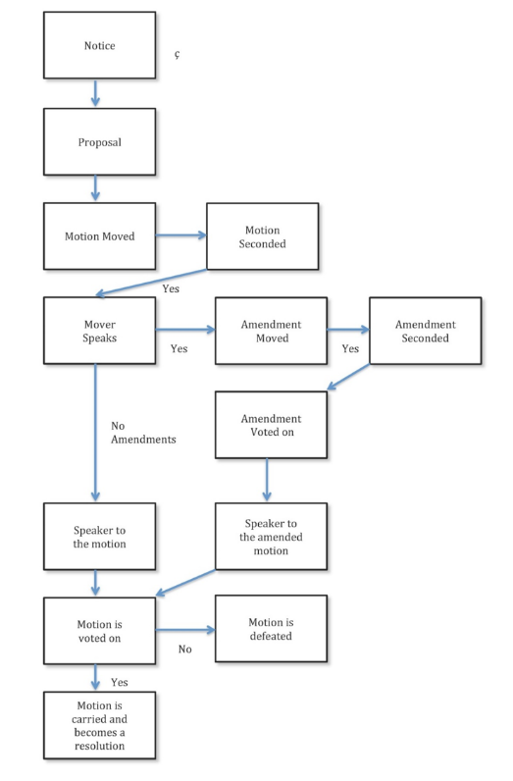
* Every meeting has a chairperson, deputy chairperson, secretary, members
  + Chairperson needs to facilitate discussion, summarise points of agreement, clarify points and issues, bring discussion to a resolution
* Minutes should have the
  + Name of meeting
  + Date and time of meeting
  + Attendance and apologies
  + Numbered items
  + Action after each item and who is responsible
  + Details of any motions who moved them and outcome
  + Time meeting was closed
* Should use the STAR approach for job interviews
  + Situation (describe the situation or scene)
  + Task (what needed to be done to address the situation and what my role/responsibility was)
  + Action (what I did and how I did it)
  + Result (what happened as a result of my action)

**Chapter 6**

* Being in teams has benefits like higher work output and higher quality of work, increased productivity, higher employee morale., higher quality decisions
* Can also have disadvantages
  + Groupthink (where the closer a group is together, the more their thinking is aligned)
    - Solved by appointing a devil’s advocate to propose a different opinion
  + Social loafing (believing that their underperformance will not be noted when put in a team)
* Teams can have different models based on structure, purpose, duration
  + Structure: Self-managed, joint decision making → Structured leadership
  + Purpose: Function-oriented → Project-oriented
  + Duration: Limited time → Ongoing
* Team Development Stages
  + Forming (getting to know each other and what their roles are)
  + Storming (Conflict with leadership, misunderstandings about role and style behaviours and norms, conflicting goals, poor feedback and listening)
  + Norming (formal and informal norms begin to emerge and cohesion between members begin to develop)
  + Performing (balance of rules and roles emerge. Group begins to be more productive)
  + Adjourning (Group reaches closure on the tasks, members of the group leave.)
* An effective team has the following
  + Shared goals and supportive environment
  + Emphasis on learning and space for mistakes
  + Clear roles
  + Participation in decision making
  + Open communication
  + Differences are recognised and handled
* Teams can have internal or external problems
  + Internal problems can be loss of enthusiasm, feeling unable to contribute properly or becoming cynical
  + Can be solved by shared goals, motivation, clear decision-making structure (e.g. consensus, majority rules, minor rule, averaging, expert, authority rule without discussion)
  + External problems can include lack of resources, poor communication within organisation and other teams, lack of management support, invisibility of the team within the organisation)

**Chapter 7**

* Morality is the rules of the society
  + An individual’s principles and understanding of right and wrong within the context of society’s rules
* Ethics is the rules of conduct for a group of people
* Rule oriented approach sets rules to follow (irrespective of the consequence)
  + e.g. Golden rule, human rights, Kantian ethics, Ten Commandments
* Consequence oriented approach involves making decisions based on the likely consequences
  + No fixed rules, each decision is made on a case-by-case basis
  + People can disagree on moral issues
* Ethical codes for professions are beneficial as it gives self-regulation as opposed to legal supervision
* ACS code of ethics has the following values
  + Primacy of the Public Interest (Interest of the public comes first)
  + Enhancement of Quality of Life (Will strive to enhance the QoL of those affected by your work)
  + Honesty (Honest in representation of your skills, knowledge, services and products)
  + Competence (Will work competently and diligently for your stakeholders)
  + Professional Development (Will enhance your own professional development and that of your staff)
  + Professionalism (will enhance the integrity of the ACS and respect of its members for each other)
* There are common ethical issues for IT users
  + Inappropriate sharing of information
* Whistleblowing is the unauthorised disclosure of info about a harmful situation after attempts to report the concerns through authorised channels have been ignored
  + Generally encouraged only if with good motive (for the public)
* Leak discloses previously confidential info

**Chapter 8**

* Intellectual property is a category that includes ways to protect intellectual work produced by an individual or organisation
  + Some IP rights are automatic (copyright) and others need applications (patents)
  + IP is transferable and can be licensed or sold to another company by the creator
* IP exists to protect the owners of the work
  + Also encourages work from people knowing their work is protected
* Trade secrets is a piece of confidential info (regarded as company property)
  + Not publicly available
  + Used by the info holder to gain economic benefit by virtue of its confidentiality
  + Info holder must have efforts to keep it confidential
  + e.g. Coca-Cola, Google’s Search Algorithm
* Non-Disclosure Agreements is an agreement between two or more people or organisations and is legally binding
  + Restricts sharing of confidential info with others
  + Specify what is confidential and how long the agreement runs for and how long the parties must keep the info confidential
* Non-Compete Clauses restrict an employee’s ability to work for direct competitors or in the immediate geographic location
  + Can vary from different time spans
* Copyright: A legal construct granting the creator of an original work a set of exclusive rights on that work for a limited time
  + Gives individuals and companies an incentive to create as they can sell/license these rights for payment
  + Protects the specific expression of an idea, not the idea itself
* Copyright infringement can either be direct (doing exact copies of protected works) or indirect infringement (authorise/approve of someone else doing the direct infringement)
* Reverse engineering is legal as copyright doesn’t protect ideas and functions, but companies must still protect against unconscious copying
* Corporate ownership: When your work involves creating something during employment → It is owned by the employer
  + Never take code to a new employer (just take the skills you have learned)
* Trademarks are distinctive identifiers of goods or services restricted for use by the owner
  + Can be words, phrases, logos, symbols, photos
  + Can lose trademark protection if the word becomes part of popular culture
* Patents provide the owner with a set of exclusive rights to prevent others from making, using or selling the invention for a period of 20 years, in exchange for public disclosure of the invention
  + Patents can be used both offensively and defensively
* Open-source software is software developed by a community of users but may be licensed
  + + Gives everyone the opportunity to improve programs
  + + Eliminates tension between obeying laws and helping others
  + – Poor quality without a lot of developers
  + – No one formally responsible for updates and bug fixes
* Creative Commons license lets the owner of the work decide how others may use the work

**Chapter 9**

**Chapter 10**

**Chapter 11**

**Chapter 12**